The Russian social organization “Russian Kyokushin Karate Federation”

Regional Social Kids Organization “Novosibirsk region
Shinkyokushinkai Karate Federation”

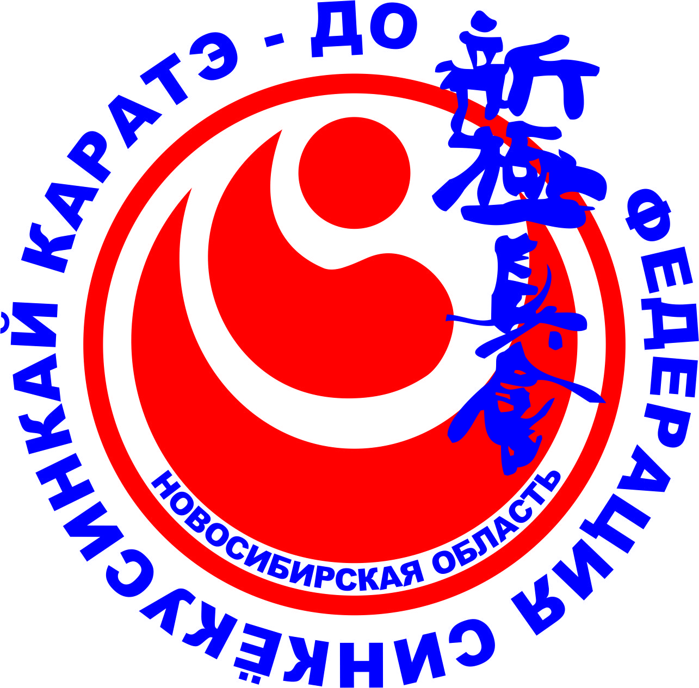
OUTLINE and OFFICIAL INVITATION
Dear Presidents of National Organizations, Country Representatives, WKO Branch Chiefs, Club Leaders, on behalf of the Russian social organization “Russian Kyokushin Karate Federation”, Regional Social Kids Organization “Novosibirsk region Shinkyokushinkai Karate Federation” and Organizing Committee, we have an honor to invite you for the
International Shinkyokushinkai Karate Championship “Andrei Yakutov 31th Memorial”
06-09.10.2023 NOVOSIBIRSK, RUSSIA
Tournament date and place: 22-25 of September 2023, Novosibirsk, Russia
Venue: SK “Sever” (Uchitelskaya str., 61, Novosibirsk, Russia)
Organizers:
Russian sport Federation “Russian Kyokusinkai Association” (AKR)
Russian social organization “Russian Kyokushin Karate Federation”
Regional Social Organization “Novosibirsk region Kyokusinkai Association”;
Regional Social Kids Organization “Novosibirsk region Shinkyokushinkai Karate Federation”;
Ministry of Sport of Novosibirsk region www.sport.nso.ru

Chief Referee: Yurii Shabanov (6th Dan, Khabarovsk, Russia)
Chief Referee deputy: Leonid Ilyushkin (6th Dan, Ulyanovsk, Russia)
Chief Secretary: Alena Mikhailova (Mosсow, Russia)
Chief Secretary deputy: Andrey Kitkin (4th Dan, Novosibirsk, Russia)

Tournament goals:
- Gaining of experience;
- Defining the strongest athletes in Kyokusinkai for Russian national Kyokusinkai team and Novosibirsk region team;
- Deepening spirit of friendship and ”fair play” between fighters and participants;
- Promotion Shinkyokushinkai karate as sport in Russia;
- Promotion of Novosibirsk as city friendly and highly developed for International Sport Events;
- Development of international relationship.

Team members:
- Official representative of team;
- Athletes (the number is not limited);
- Doctor of team (if any);
- Judges having personal judge uniform (dark blue shirt, white bow tie, black trousers and individual whistle) (Appendix 3)
- Coaches-seconds (requirements are regulated by Rules of Kyukusinkai).

Conditions of participation:
- In Championship are allowed to participate athletes if Russian Federation members of Russian Kyokusinkai Association and other countries – members of International organizations WKO, IKO, IFK, KAN.
- Registration of teams (athletes, coaches, judges, officials, supporters) (Appendix 1A) should be made via e-mail z.fsknso@bk.ru till the 01th of September 2023. For those who need visa support the deadline for registration is the 01th of August 2023 (Appendix 6)
- Appendix 1, Appendix 1А, Appendix 2, Appendix 3, Appendix 4, Appendix 5, should be made via e-mail z.fsknso@bk.ru till the 01th of September 2023
- Every representative of team, making application for participation, is highly responsible for all the datas about members of team given to mandatory commission;
- In individual program of competition (Kumite, Kata) only athletes of 12-17 years old are allowed. The age of athletes if defined for the date of mandatory commission (the 22th of September 2023). All competitors must prove their age by presenting their passport or identification card at the official weigh-in. For all the athletes a written consent must be submitted at the registration, signed by one of the parents or legal guardians, accepting their participation and all parts of the official invitation.
- For participation only athletes having qualification the 8th Kyu and above and competition experience are allowed.

Documents required to provide at mandatory commission:
- Filled in application for participation (Appendix 1);
- Passport / identification card or birth certificate;
- Document of obligatory medical insurance;
- Personal injury insurance valid for the dates of Championship;
- Personal Indemnification form (Appendix 5) and liability declaration (for minor aged) (Appendix 2) filled in and undersigned in a proper way;
- Medical proof (undersigned by doctor giving this proof) that athlete is allowed to participate in the International Shinkyokushinkai Karate Championship “Andrei Yakutov 31th Memorial”.
Age and Weight categories:
Age category | Discipline
Cadets male 12-13 years old | Кata
Cadets female 12-13 years old | Кata
Cadets male 14-15 years old | Кata
Cadets female 14-15 years old | Кata
Juniors male 16-17 years old | Кata
Juniors female 16-17 years old | Кata
Cadets male 12-13 years old | -30 kg; -35 kg; -40 kg; -45 kg; -50 kg; -55 kg; 55+ kg
Cadets female 12-13 years old | -35 kg; -40 kg; -45 kg; -50 kg; 55 kg, 55+ kg
Cadets male 14-15 years old | -40 kg; -45 kg; -50 kg; -55 kg; -60 kg; -65 kg; 65+ kg
Cadets female 14-15 years old | -40 kg; -45 kg; -50 kg; -55 kg; 55+ kg
Juniors male 16-17 years old | -50 kg; -55 kg; -60 kg; -65 kg; -70 kg; 70+ kg
Juniors female 16-17 years old | -45 kg; -50 kg; -55 kg; -60 kg, 60+ kg

Competition system and contest time:
The tournament will be held according to the WKO (World Karate Organization – Shinkyokushinkai) competition rules. Competition is held by Olympic system with elimination after 1 defeat. Athlete who loses in semi final wins the 3rd place.
Kumite
Cadets 12-13 years old (male, female)
2 min (main time) + 1 min (first extra time) + 1 min (last extra time with obligatory decision of Judges)
Cadets 14-15 years old (male, female)
2 min (main time) + 2 min (first extra time) + 1 min (last extra time with obligatory decision of Judges)
Juniors 16-17 years old (male, female)
2 min (main time) + 2 min (first extra time) + 2 min (last extra time with obligatory decision of Judges)
The weight of athletes is not taken into account.
Kata
On tatami are invited 2 athletes (one with red armband and another one with white armband). They make Kata in turn, then judge defines the winner. Kata by choice in semi-finals and final can’t be repeated. Exact number of rounds will be defined after registration of preliminary applications of teams.

Age category | Preliminary  Kata | Quarter final Kata | Semi-final, final  Кata by choice
10-11 yo | Pin-an 1 | Pin-an 2 | Pin-an 3-5
12-13 yo | Pin-an 2 | Pin-an 3 | Pin-an 4-5,  Tsuki No
14-15 yo | Pin-an 3 | Pin-an 4 | Pin-an 5, Tsuki No, Yantsu.
16-17 yo | Pin-an 4 | Pin-an 5 | Tsuki No, Yantsu, Gekusai Dai Gekusai Sho.

If an athlete is not present on tatami within 1 min after his / her surname is announced defeat is declared.
Categories can be changed or cancelled due to insufficient quantity of participants after registration of preliminary applications of teams.

Equipment required:
Every participant should be equipped with:
- white dogi and belt according to qualification of athlete. Emblems and chevrons are allowed according to the rules of WKO;
- individual groin protection (for males);
- bandage of definite sample (for females);
- shin and instep protectors;
- helmet;
- arm protectors;
- mouth guard – voluntarily, except case when athlete uses brackets.
Every participant allowed for Competitions must have mentioned above individual equipment of WKO standard or analog of white color. Equipment should be provided for revision.

Program of Championship:
Date | Address | Schedule
The 22th of September 2023 | “Marins Park Hotel Novosibirsk” (Vokzalnaya magistral, 1) | Arrival of teams.  09.00-18.00 – mandatory commission, weigh-in  18.00 – judge seminar
The 23th of September 2023 | Ippodromskaya str., 18 (region volleyball center “Lokomotiv-Arena”) | 09.00 – kata in all the age categories  11.00 – kumite fights till semi- finals in all the age and weight categories
The 24th of September 2023 | Ippodromskaya str., 18 (region volleyball center “Lokomotiv-Arena”) | 09.00 – semi-finals in all the age and weight categories  12.30 – break before official Opening Ceremony  13.00 – official Opening Ceremony  14.00 – finals in all the age and weight categories  18.00 – awarding ceremony
The 25th of September 2023 |  | Departure of teams

Accommodation:
Official hotel of competition is “Marins Park Hotel Novosibirsk” (Vokzalnaya magistral, 1).
The deadline for applications for accommodation (Appendix 4) is the 1st of September 2023. Applications should be sent to the following e-mail: z.fsknso@bk.ru
For teams who will choose accommodation in official hotel transfer from airport of Novosibirsk to the hotel and venue (and back) will be provided.

Anti-doping:
The WKO Anti-Doping Rules (2021 version) and WADA Anti-Doping Code are applicable. Compulsory random doping tests can be conducted among the athletes. Therapeutic Use Exemption Athletes who take any substance or medicine listed in the “Prohibited List” of the WADA Anti-Doping Code for therapeutic purposes are requested to inform the Organizers not later than 1 of September 2023.

Medical insurance:
All participating athletes, coaches and team officials shall have mandatory a medical insurance that covers medical care and in case of emergency repatriation to home country. All relevant documents proving that such an insurance is present, including insurance policy papers, should be taken to the event in case a medical situation occurs.

Visa support:
It is highly recommended that foreigners, who wish to visit Russia, should read the related information about our country’s visa regime on the site of Russian Embassy in Your country. Visa regime for Touristic and Business Purposed visit of a country may differ from Work and Education Purposed visit. Please contact the Organizing Committee for support in acquiring your visa at z.fsknso@bk.ru (Appendix 6).

Indemnities:
It is the responsibility of each registering team to ensure that their athletes and team officials have filled in the indemnification forms correctly and have duly signed them, thereby indemnifying Regional Social Kids Organization “Novosibirsk region Shinkyokushinkai Karate Federation”, and Regional Social Organization “Novosibirsk region Kyokusinkai Association”, and the Organizing Committee and all other officials and athletes from any claims of injuries, losses or otherwise arising in the course of participation at the International Shinkyokushinkai Karate Championship “Andrei Yakutov 31th Memorial” or any activities linked therewith. It is the responsibility of each registered team to ensure and guarantee that sufficient insurance coverage has been arranged for all athletes, team officials and other participants. Without sufficient insurance coverage, teams will not be allowed to compete. Please fill in the Personal Indemnity Forms and provide them to the Organization Committee before the 01th of September 2023. Each participant (athletes, team officials, etc.) has to fill in the indemnification form.

IMPORTANT INFORMATION:
All the expenses concerning participation in competition (trip costs, accommodation, visa costs, insurance, entry fee etc.) of athletes, officials, judges are carried by delegating organizations.
Entry fee is 2500 rub (if athlete takes part in kata or kumite only. In case if athlete participates in both – kata and kumite – entry fee will be 3000 rub in total)

Contacts:
If you have any questions don’t hesitate to contact us.
Responsible for team transfer to the place of accommodation and venue – Magurdumian David, cell nr. +79137303664.
Executive officer of the Regional Social Kids Organization “Novosibirsk region Shinkyokushinkai Karate Federation” Andrey Kitkin, cell nr. +79137657777.
Organizing Committee: e-mail: fsknso@bk.ru., phone nr. +73832557080, address: Lazurnaya str. 10/2, Novosibisk, Russian Federation, 630051

WE ARE LOOKING FORWARD TO SEEING YOU SOON IN NOVOSIBIRSK!

